**Kubernetes Setup with MiniKube Windows**

**Overview**

Open Powershell as Admin

Setup Chocolaty

Install Minikube with Chocolaty

Step1 : Open gitbash and clone vprofile project from kubernetes-setup branch

$ git clone https://github.com/Abhijeet41/vprofile-project.git -b kubernetes-setup

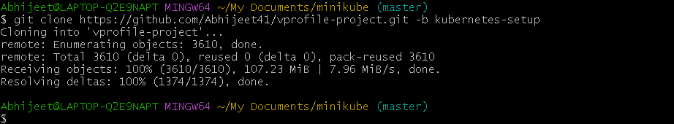

Step2 : Install Minikube first open poweshell as admin and type

Below command

choco install minikube kubernetes-cli -y

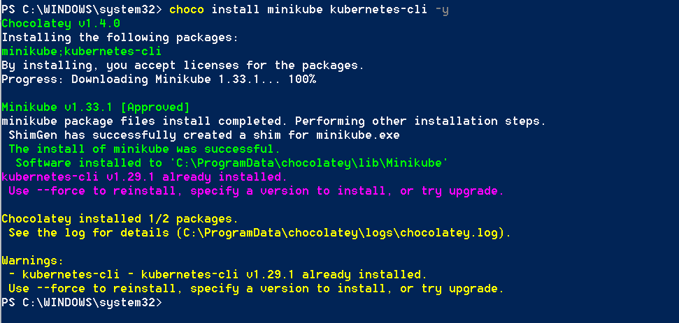

Now start minikube using below command

minikube start

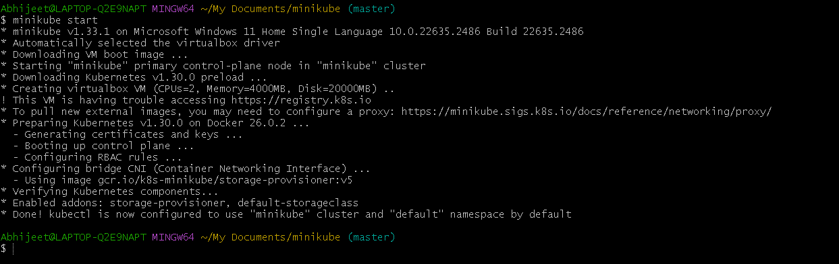

Note above process take 15min

Now to check master node is created or not using below command

$ kubectl get nodes



Check on virtual machine box minikube is running…

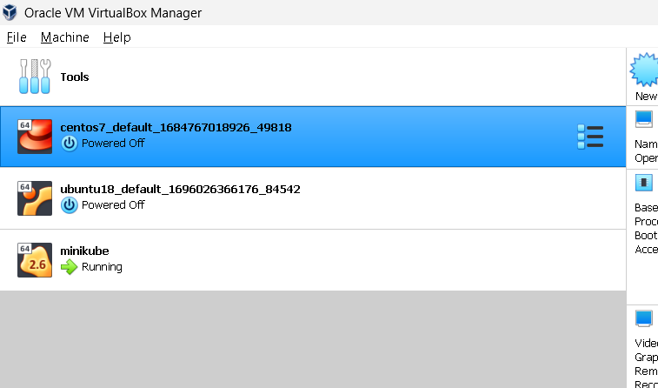

$ cat .kube/config

apiVersion: v1

clusters:

- cluster:

certificate-authority-data: 

server: https://api.kubevpro.devbytesschool.info

tls-server-name: api.internal.kubevpro.devbytesschool.info

name: kubevpro.devbytesschool.info

- cluster:

certificate-authority: C:\Users\Abhijeet\.minikube\ca.crt

extensions:

- extension:

last-update: Sun, 16 Jun 2024 14:57:54 IST

provider: minikube.sigs.k8s.io

version: v1.33.1

name: cluster_info

server: https://192.168.59.100:8443

name: minikube

contexts:

- context:

cluster: kubevpro.devbytesschool.info

user: kubevpro.devbytesschool.info

name: kubevpro.devbytesschool.info

- context:

cluster: minikube

extensions:

- extension:

last-update: Sun, 16 Jun 2024 14:57:54 IST

provider: minikube.sigs.k8s.io

version: v1.33.1

name: context_info

namespace: default

user: minikube

name: minikube

current-context: minikube

kind: Config

preferences: {}

users:

- name: kubevpro.devbytesschool.info

user:

client-certificate-data: 

client-key-data: 

- name: minikube

user:

client-certificate: C:\Users\Abhijeet\.minikube\profiles\minikube\client.crt

client-key: C:\Users\Abhijeet\.minikube\profiles\minikube\client.key

$ kubectl.exe get nodes

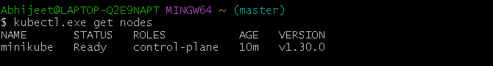

Using below link we create and deploy hello world in minikube

<https://kubernetes.io/docs/tutorials/hello-minikube/>

kubectl create deployment hello-node --image=registry.k8s.io/e2e-test-images/agnhost:2.39 -- /agnhost netexec --http-port=8080



Using this below command check working fine

$ kubectl.exe get pods

$ kubectl.exe get deploy

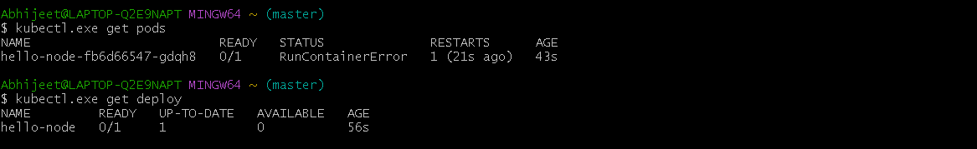

Expose the Pod to the public internet using the kubectl expose command:

kubectl expose deployment hello-node --type=LoadBalancer --port=8080



To checked service is deployed or not using this command

$ minikube service hello-node –url

